# INDEX

|  |  |
| --- | --- |
| **NAME OF CONTENTS ABSTRACT CHAPTER-1** | **PAGE NO** |
| 1. INTRODUCTION | 4 -11 |
| **CHAPTER-2**  2. LITERATURE REVIEW | 12-14 |
| **CHAPTER-3**  3 .PROPOSED SYSTEM | 15 |
| 3.1 BLOCK AND CIRCUIT DIAGRAM | 16 |
| **CHAPTER-4**  4. HARDWARE COMPONENTS | 17 |
| POWER SUPPLY | 17 |
| ARDUNIO | 19 |
| FEATURES | 20 |
| HARDWARE COMPONENTS | 22 |
| EXPLANATION ABOUT COMPONENTS SOFTWARE | 23  26 |
| **CHAPTER-5**  5.RESULT | 39 |

|  |  |
| --- | --- |
| **CHAPTER-6** |  |
| 6. CONCLUSION | 40 |
| **CHAPTER-7**  7. REFERENCES | 41-42 |

**ABSTRACT**:-

Technology is a never ending process. To be able to design a product using the current technology that will be beneficial to the lives of others is a huge contribution to the community. This paper presents the design and implementation of a low cost but yet flexible and secure cell phone based home automation system. The design is based on a standalone Arduino BT board and the home appliances are connected to the input/ output ports of this board via relays. The communication between the cell phone and the Arduino BT board is wireless. This system is designed to be low cost and scalable allowing variety of devices to be controlled with minimum changes to its core. Password protection is being used to only allow authorized users fromaccessing the appliances at home.

|  |  |  |
| --- | --- | --- |
| **LIST OF FIGURES**  **FIGURE NO** | **NAME OF THE FIGURE** | **PAGE NO** |
| 1.1 | Layered architecture of an embedded system | 6 |
| 1.2 | Block diagram of Embedded system architecture | 7 |
| 3.1  3.2 | Block diagram  Circuit diagram | 15  16 |
| 4.1 | Block diagram of power supply | 17 |
| 4.2 | Power supply circuit diagram | 18 |
| 4.3 | Arduino Nano | 23 |
| 4.4 | Bluetooth Module | 24 |
| 4.5 | Relay | 25 |
| 4.6 | LCD I2C module | 25-26 |
| 4.10 | Software logo | 27 |
| 4.11 | Arduino Nano | 27 |
| 4.12 | A-to-B USB cable | 28 |
| 4.13 | Device manager | 29 |
| 4.14 | Examples | 31 |
| 4.15 | Selection of board | 32 |
| 4.16 | Selection of serial port | 32 |
| 4.17  5.1 | Example code  Front view and Side view of kit | 33  39 |

# CHAPTER 1: INTRODUCTION

Home automation system is use of information technologies and control system to reduce the human labor. The rapid growth of technologies influence us to use smartphones to remotely control the home appliances. An automated devices has ability to work with versatility, diligence and with lowest error rate. The idea of home automation system is a significant issue for Researchers and home appliances companies. Automation system not only helps to decrease the human labor but it also saves time and energy. Early home automation systems were used in labor saving machines but nowadays its main objective is provide facilities to elderly and handicapped people to perform their daily routine tasks and control the home appliances remotely. A Bluetooth based wireless home automation system can be implement with a low cost and it is easy to install in an existing home. A research work proved that Bluetooth system are faster than wireless and GSM systems. Bluetooth technology has ability to transmit data serially up to 3 Mbps within a physical range of 10m to 100m depending on the type of Blue tooth device. The design of proposed method is based on Arduino board, Bluetooth module, sensors and smartphone application. Bluetooth module HC-05 is interfaced with Arduino board and home appliances are connected with Arduino board via relay. Smartphone application is used for serial communication between smartphone and Bluetooth module which is further connected with Arduino board. II. RELATED WORK Several remote controlled home automation systems have been studied. R.Piyare and M.Tazil research work provided full functionality to remotely control home appliances via wireless communication between the Arduino BT and cell phone using Bluetooth technology. Arduino BT board was connected with home appliance and it was controlled by a Symbian OS cell phone application. Similarly, another study presented home automation system using Bluetooth and android application. However, this was designed only for 4 lights and it was not feasible to control more than 4 Home appliances. In another research work, XBee based home automation system introduced for handicapped and elderly people. XBee transceivers was used for wireless communication between the master control panel board and the remote control device. A home monitoring and automation system was also studied, it was implemented by using Arduino Nano and Digilent chipKIT. Although this system mentioned as low cost system but it is much expensive than Bluetooth base home automation system. A low cost and wireless controlled automation system was designed by researchers. Bluetooth technologywas used to provide remote controlled wireless access to user.

### Introduction To Embedded Systems

An embedded system can be defined as a computing device that does a specific focused job. Appliances such as the air-conditioner, VCD player, DVD player, printer, fax

machine, mobile phone etc. are examples of embedded systems. Each of these appliances will have a processor and special hardware to meet the specific requirement of the application along with the embedded software that is executed by the processor for meeting that specific requirement. The embedded software is also called “firm ware”. The desktop/laptop computer is a general purpose computer. You can use it for a variety of applications such as playing games, *word* processing, accounting, software development and so on. In contrast, the software in the embedded systems is always fixed listed below:

Embedded systems do a very specific task, they cannot be programmed to do different things. Embedded systems have very limited resources, particularly the memory. Generally, they do not have secondary storage devices such as the CDROM or the floppy disk. Embedded systems have to work against some deadlines. A specific job has to be completed within a specific time. In some embedded systems, called real-time systems, the deadlines are stringent. Missing a deadline may cause a catastrophe-loss of life or damage to property. Embedded systems are constrained for power. As many embedded systems operate through a battery, the power consumption has to be very low. Some embedded systems have to operate in extreme environmental conditions such as very high temperatures and humidity.

##### Overview Of Embedded System Architecture

Every embedded system consists of custom-built hardware built around a Central Processing Unit (CPU). This hardware also contains memory chips onto which the software is loaded.

The software residing on the memory chip is also called the ‘firmware’. The embedded system architecture can be represented as a layered architecture as shown in Fig.

The operating system runs above the hardware, and the application software runs above the operating system. The same architecture is applicable to any computer including a desktop computer. However, there are significant differences. It is not compulsory to have an operating system in every embedded system. For small appliances such as remote control units, air conditioners, toys etc., there is no need *for* an operating system and you can write

onlythe software specific to that application.

For applications involving complex processing, it is advisable to have an operating system. In

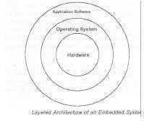

##### Fig 1.1 : Layered architecture of an embedded system

such a case, you need to integrate the application software with the operating system and then transfer the entire software on to the memory chip. Once the software is transferred to the memory chip, the software will continue to run *for* a long time you don’t need to reload new software.

Now, let us see the details of the various building blocks of the hardware of an embedded system. As shown in Fig. the building blocks are;

Central Processing Unit (CPU)

* Memory(Read-only Memory and Random Access Memory)
* Input Devices
* Output devices
* Communication interfaces

* 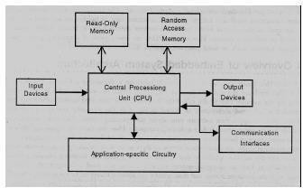

##### * Fig 1.2 : Block diagram of Embedded system architecture

*

* Application-specific circuitry

##### Central Processing Unit (CPU)

The Central Processing Unit (processor, in short) can be any of the following: microcontroller, microprocessor or Digital Signal Processor (DSP). A micro-controller is a low-cost processor. Its main attraction is that on the chip itself, there will be many other components such as memory, serial communication interface, analog-to digital converter etc. So, for small applications, a micro-controller is the best choice as the number of external components required will be very less. On the other hand, microprocessors are more powerful, but you need to use many external components with them. D5P is used mainly for applications in which signal processing is involved such as audio and video processing.

##### Memory

The memory is categorized as Random Access 11emory (RAM) and Read Only Memory (ROM). The contents of the RAM will be erased if power is switched off to the chip, whereas ROM retains the contents even if the power is switched off. So, the firmware is stored in the ROM. When power is switched on, the processor reads the ROM; the program is program is executed.

##### Input devices

Unlike the desktops, the input devices to an embedded system have very limited capability. There will be no keyboard or a mouse, and hence interacting with the embedded system is no easy task. Many embedded systems will have a small keypad-you press one key to give a specific command. A keypad may be used to input only the digits. Many embedded systems used in process control do not have any input device *for* user interaction; they take inputs *from* sensors or transducers 1’fnd produce electrical signals that are in turn fed to other systems.

##### Output devices

The output devices of the embedded systems also have very limited capability. Some embedded systems will have a *few* Light Emitting Diodes (LEDs) *to* indicate the health status of the system modules, or *for* visual indication of alarms. A small Liquid Crystal Display (LCD) may also be used to display *some* important parameters.

##### Communication interfaces

The embedded systems may need to, interact with other embedded systems at they may have to transmit data to a desktop. To facilitate this, the embedded systems are provided with one or a *few* communication interfaces such as RS232, RS422, RS485, Universal Serial Bus (USB), IEEE 1394, Ethernet etc.

##### Application-specific circuitry

Sensors, transducers, special processing and control circuitry may be required fat an embedded system, depending on its application. This circuitry interacts with the processor to carry out the necessary work. The entire hardware has to be given power supply either through the 230 volts main supply or through a battery. The hardware has to design in such a waythat the power consumption is minimized.

##### Following Are The Advantages Of Embedded Systems

1. They are designed to do a specific task and have real time performance constraints which must be met.
2. Theyallow the system hardware to be simplified so costs are reduced.
3. They are usually in the form of small computerized parts in larger devices which serve a general purpose.

##### Application Areas

Nearly 99 per cent of the processors manufactured end up in embedded systems. The embedded system market is one of the highest growth areas as these systems are used in very market segment- consumer electronics, office automation, industrial automation, biomedical engineering, wireless communication, data communication, telecommunications, transportation, military and so on.

##### Consumer appliances

At home we use a number of embedded systems which include digital camera, digital diary, DVD player, electronic toys, microwave oven, remote controls for TV and air- conditioner, VCO player, video game consoles, video recorders etc. Today’s high-tech car has about 20 embedded systems for transmission control, engine spark control, air- conditioning, navigation etc. Even wristwatches are now becoming embedded systems. The palmtops are powerful embedded systems using which we can carry out many general- purpose tasks such as playing games and word processing.

##### Office automation

The office automation products using em embedded systems are copying machine, fax machine, keytelephone, modem, printer, scanner etc.

##### Industrial automation

Today a lot of industries use embedded systems for process control. These include pharmaceutical, cement, sugar, oil exploration, nuclear energy, electricity generation and transmission. The embedded systems for industrial use are designed to carry out specific tasks such as monitoring the temperature, pressure, humidity, voltage, current etc., and then take appropriate action based on the monitored levels to control other devices or to send information to a centralized monitoring station. In hazardous industrial environment, where human presence has to be avoided, robots are used, which are programmed to do specific jobs. The robots are now becoming very powerful and carry out many interesting and complicated tasks such as hardware assembly.

##### Medical electronics

Almost every medical equipment in the hospital is an embedded system. These equipments include diagnostic aids such as ECG, EEG, blood pressure measuring devices, X-ray scanners; equipment used in blood analysis, radiation, colonscopy, endoscopy etc. Developments in medical electronics have paved way for more accurate diagnosis of diseases.

##### Computer networking

Computer networking products such as bridges, routers, Integrated Services Digital Networks (ISDN), Asynchronous Transfer Mode (ATM), X.25 and frame relay switches are embedded systems which implement the necessary data communication protocols. For

example, a router interconnects two networks. The two networks may be running different protocol stacks. The router’s function is to obtain the data packets from incoming pores, analyze the packets and send them towards the destination after doing necessary protocol conversion. Most networking equipments, other than the end systems (desktop computers) we use to access the networks, are embedded systems

##### Telecommunications

In the field of telecommunications, the embedded systems can be categorized as subscriber terminals and network equipment. The subscriber terminals such as key telephones, ISDN phones, terminal adapters, web cameras are embedded systems. The network equipment includes multiplexers, multiple access systems, Packet Assemblers Dissemblers (PADs), satel1ite modems etc. IP phone, IP gateway, IP gatekeeper etc. are the latest embedded systems that provide very low-cost voice communication over the Internet.

##### Wireless technologies

Advances in mobile communications are paving way for many interesting applications using embedded systems. The mobile phone is one of the marvels of the last decade of the 20th century. It is a very powerful embedded system that provides voice communication while we are on the move. The Personal Digital Assistants and the palmtops can now be used to access multimedia services over the Internet. Mobile communication infrastructure such as base station controllers, mobile switching centers are also powerful embedded systems.

##### Insemination

Testing and measurement are the fundamental requirements in all scientific and engineering activities. The measuring equipment we use in laboratories to measure parameters such as weight, temperature, pressure, humidity, voltage, current etc. are all embedded systems. Test equipment such as oscilloscope, spectrum analyzer, logic analyzer, protocol analyzer, radio communication test set etc. are embedded systems built around powerful processors. Thank to miniaturization, the test and measuring equipment are now becoming portable facilitating easytesting and measurement in the field by field-personnel.

##### Security

Security of persons and information has always been a major issue. We need to protect our homes and offices; and also the information we transmit and store. Developing embedded systems for security applications is one of the most lucrative businesses nowadays. Security

devices at homes, offices, airports etc. for authentication and verification are embedded systems. Encryption devices are nearly 99 per cent of the processors that are manufactured end up in~ embedded systems. Embedded systems find applications in.every industrial segment-consumer electronics, transportation, avionics, biomedical engineering, manufacturing, process control and industrial automation, data communication, telecommunication, defense, security etc. Used to encrypt the data/voice being transmitted on communication links such as telephone lines. Biometric systems using fingerprint and face recognition are now being extensively used for user authentication in banking applications as well as for access control in high security buildings.

##### Finance

Financial dealing through cash and cheques are now slowly paving way for transactions using smart cards and ATM (Automatic Teller Machine, also expanded as Any Time Money) machines. Smart card, of the size of a credit card, has a small micro-controller and memory; and it interacts with the smart card reader! ATM machine and acts as an electronic wallet. Smart card technology has the capability of ushering in a cashless society. Well, the list goes on. It is no exaggeration to say that eyes wherever we go, we can see, or at least feel, the work of an embedded system.

# CHAPTER 2: LITTERATURE SURVEY

#### D. H. Stefanov, Zeungnam Bien and Won-Chul Bang, "The smart house for older persons and persons with physical disabilities: structure, technology arrangements, and perspectives,"

Smart houses are considered a good alternative for the independent life of older persons and persons with disabilities. Numerous intelligent devices, embedded into the home environment, can provide the resident with both movement assistance and 24-h health monitoring. Modern home-installed systems tend to be not only physically versatile in functionality but also emotionally human-friendly, i.e., they may be able to perform their functions without disturbing the user and without causing him/her any pain, inconvenience, or movement restriction, instead possibly providing him/her with comfort and pleasure. Through an extensive survey, this paper analyzes the building blocks of smart houses, with particular attention paid to the health monitoring subsystem as an important component, by addressing the basic requirements of various sensors implemented from both research and clinical perspectives. The paper will then discuss some important issues of the future development of an intelligent residential space with a human-friendly health monitoring functional system.

**C. Douligeris, "Intelligent home systems,"** Abstract: The home automation system module, communications standards developed in the US by the Electronic Industry Association (EIA) and known as the Consumer Electronic Bus (CEBus) is reviewed. The CEBus network node architecture application layer, network layer, data link layer, physical layer, and access protocol are discussed. The different media used for CEBus communication

#### A. R. Al-Ali and M. Al-Rousan, "Java-based home automation system," and implementation of a Java-based automation system that can monitor and control home appliances via the World Wide Web

. The design is based on a stand alone embedded system board integrated into a PC- based server at home. The home appliances are connected to the input/output ports of the embedded system board and their status are passed to the server. The monitoring and control software engine is based on the combination of JavaServer pages, JavaBeans, and interactive C. The home appliances can be monitored and controlled locally via the embedded system board, or remotely through a Web browser from anywhere in the world provided that an Internet access is available. The system is scalable and allows multi-vendor appliances to be added with no major changes to its core. Password protection is used to block unauthorized users from accessing the appliances at home. If the Internet connection is down or the server is not up, the embedded system board still can control and operate the appliances locally.

#### R. J. C. Nunes and J. C. M. Delgado, "An Internet application for home automation,"

Abstract: Describes an Internet application that allows local and remote monitoring and control of a home. The application adopts an object-oriented philosophy, in which every home automation device is represented by an object. This leads to an integrated view of the home, with a common look-and-feel across all the devices, while supporting various methods of actuation and sensing. The application runs on a PC with a Web server. The user interface is implemented through a standard browser using common HTML pages or Java applets. The interaction with the home control system(s) is done through specific hardware or standard PC interfaces such as the serial port or USB, or by LAN. The application offers a powerful way of controlling and programming the behavior of the home, using

scripts. For the common user, a simpler version of a script - a scenario - may be used. A scenario consists of a set of devices in a particular state and can be activated directly by the user, by a time stimulus or by any event in the home.

# CHAPTER 3: PROPOSED SYSTEM

Wireless technologies are rapidly growing, also becoming very illustrious and extensively being used everywhere and the clients appreciate the convenient and easy lifestyle of being wireless. Nowadays with the engrained Bluetooth technology, various digital devices build a system in which the appliances and the devices are interconnected with each other. The Bluetooth technology could be used as one of the significant communication attribute in automation system. The range of communication is 10 to 100mts depending on the version of Bluetooth technology and operates on freely available 2.4GHz bandwidth spectrum. With this capability of Bluetooth; in this paper, a Bluetooth technology based home automation system is proposed enabling elderly and physically disabled people to control the home appliances through their voice commands. Implementation of this proposed automation system has proved its efficiency.

* 1. **BLOCK DIAGRAM**

ARDUINO NANO

BLUETOOTH MODULE

RELAY

LCD

LCD I2C ADAPTER

* 1. **CIRCUIT DIAGRAM**

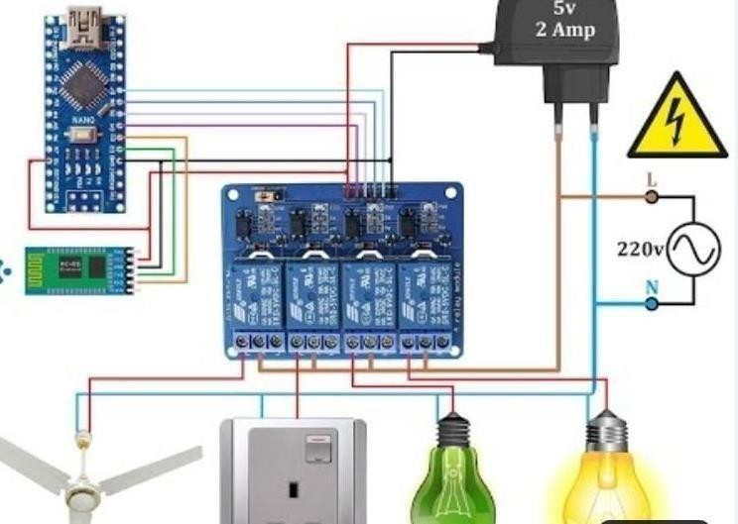

# CHAPTER 4: HARDWARE COMPONENTS

##### 4.1 Power Supply

The input to the circuit is applied from the regulated power supply. The a.c. input i.e., 230V from the mains supply is step down by the transformer to 12V and is fed to a rectifier. The output obtained from the rectifier is a pulsating d.c voltage. So in order to get a pure d.c voltage, the output voltage from the rectifier is fed to a filter to remove any a.c components present even after rectification. Now, this voltage is given to a voltage regulator to obtain a pure constant dc voltage.

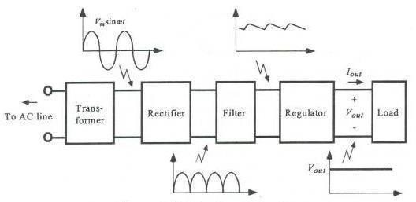

##### Transformer:

Usually, DC voltages are required to operate various electronic equipment and these voltages are 5V, 9V or 12V. But these voltages cannot be obtained directly. Thus the a.c input available at the mains supply i.e., 230V is to be brought down to the required voltage level. This is done by a transformer. Thus, a step down transformer is employed to decrease the voltage to a required level.

##### Rectifier:

The output from the transformer is fed to the rectifier. It converts A.C. into pulsating

D.C. The rectifier may be a half wave or a full wave rectifier. In this project, a bridge rectifier is used because of its merits like good stability and full wave rectification.

##### Filter:

Capacitive filter is used in this project. It removes the ripples from the output of rectifier and smoothens the D.C. Output received from this filter is constant until the mains voltage and load is maintained constant. However, if either of the two is varied, D.C. voltage received at this point changes. Therefore a regulator is applied at the output stage.

##### Voltage regulator:

As the name itself implies, it regulates the input applied to it. A voltage regulator is an electrical regulator designed to automatically maintain a constant voltage level. In this project, power supply of 5V and 12V are required. In order to obtain these voltage levels, 7805 and 7812 voltage regulators are to be used. The first number 78 represents positive supply and the numbers 05, 12 represent the required output voltage levels.

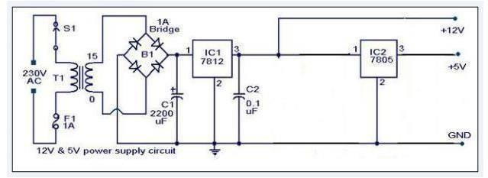

##### Fig 4.2 : Power supply circuit diagram

**ARDUINO**

**Arduino** is an open-source computer hardware and software company, project and user community that designs and manufactures single-board microcontrollers and microcontroller kits for building digital devices and interactive objects that can sense and control objects in the physical and digital world. The project's products are distributed as open-source hardware and software, which are licensed under the GNU Lesser General Public License (LGPL) or the GNU General Public License (GPL),permitting the manufacture of Arduino boards and software distribution by anyone. Arduino boards are available commercially in preassembled form or as do-it-yourself (DIY) kits.

Arduino board designs use a variety of microprocessors and controllers. The boards are equipped with sets of digital and analog input/output (I/O) pins that may be interfaced to various expansion boards or breadboards (*shields*) and other circuits. The boards feature serial communications interfaces, including Universal Serial Bus (USB) on some models, which are also used for loading programs from personal computers. The microcontrollers are typically programmed using a dialect of features from the programming languages C and C++. In addition to using traditional compiler toolchains, the Arduino project provides an integrated development environment (IDE) based on the Processing language project.

The Arduino project started in 2003 as a program for students at the Interaction Design Institute Ivrea in Ivrea, Italy.aiming to provide a low-cost and easy way for novices and professionals to create devices that interact with their environment using sensors and actuators. Common examples of such devices intended for beginner hobbyists include simple robots, thermostats and motion detectors.

The name *Arduino* comes from a bar in Ivrea, Italy, where some of the founders of the project used to meet. The bar was named after Arduin of Ivrea, who was the margrave of the March of Ivrea and King of Italy from 1002 to 1014.

##### Features

1. High Performance, Low Power Atmel AVR 8-Bit Microcontroller Family
   * Advanced RISC Architecture
     + 131 Powerful Instructions
     + Most Single Clock Cycle Execution
     + 32 x 8 General Purpose Working Registers
     + Fully Static Operation
     + Up to 20 MIPS Throughput at 20MHz
     + On-chip 2-cycle Multiplier
   * High Endurance Non-volatile Memory Segments
     + 32KBytes of In-System Self-Programmable Flash program
2. Memory

* 1KBytes EEPROM
* 2KBytes Internal SRAM
* Write/Erase Cycles: 10,000 Flash/100,000 EEPROM
* Data Retention: 20 years at 85°C/100 years at 25°C(1)
* Optional Boot Code Section with Independent Lock Bits
* In-System Programming by On-chip Boot Program
* True Read-While-Write Operation
  + Programming Lock for Software Security
* Atmel® QTouch® Library Support
  + Capacitive Touch Buttons, Sliders and Wheels
  + QTouch and QMatrix® Acquisition
  + Up to 64 sense channels

1. Atmel-42735B-ATmega328/P_Datasheet_Complete-11/2016
   * Peripheral Features
     + Two 8-bit Timer/Counters with Separate Prescaler and Compare Mode
     + One 16-bit Timer/Counter with Separate Prescaler, Compare Mode, and Capture Mode
     + Real Time Counter with Separate Oscillator
     + Six PWM Channels
     + 8-channel 10-bit ADC in TQFP and QFN/MLF package
   * Temperature Measurement
     + 6-channel 10-bit ADC in PDIP Package
   * Temperature Measurement
     + Two Master/Slave SPI Serial Interface
     + One Programmable Serial USART
     + One Byte-oriented 2-wire Serial Interface (Philips I2C compatible)
     + Programmable Watchdog Timer with Separate On-chip Oscillator
     + One On-chip Analog Comparator
     + Interrupt and Wake-up on Pin Change
   * Special Microcontroller Features
     + Power-on Reset and Programmable Brown-out Detection
     + Internal Calibrated Oscillator
     + External and Internal Interrupt Sources
     + Six Sleep Modes: Idle, ADC Noise Reduction, Power-save, Power- down, Standby, and
2. Extended Standby
   * I/O and Packages
     + 23 Programmable I/O Lines
     + 28-pin PDIP, 32-lead TQFP, 28-pad QFN/MLF and 32-pad QFN/MLF
   * Operating Voltage:
     + 1.8 - 5.5V
   * Temperature Range:
     + -40°C to 105°C
   * Speed Grade:
     + 0 - 4MHz @ 1.8 - 5.5V
     + 0 - 10MHz @ 2.7 - 5.5V
     + 0 - 20MHz @ 4.5 - 5.5V
   * Power Consumption at 1MHz, 1.8V, 25°C
     + Active Mode: 0.2mA
     + Power-down Mode: 0.1μA
     + Power-save Mode: 0.75μA (Including 32kHz RTC)

##### HARDWARE COMPONENTS

ARDUINO NANO BLUETOOTH MODULE LCD I2C

RELAY 4 – CHANNEL JUMPER WIRES

DC FAN BULBS MOTOR

POWER SOCKET

**EXPLANATION ABOUT COMPONENTS**

## ARDUINO NANO

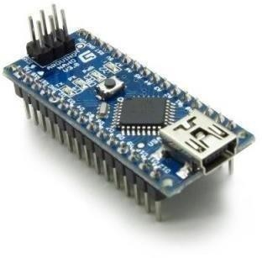

##### Fig 4.3 : ARDUINO NANO

NANO Version 3 is the open source smallest Embedded Development board based on Atmega328 SMD Package Microcontroller. It is a Surface mount Breadboard Friendly board integrated with Mini USB Port. DC Power Jack is not available on this Board, so power can be given through Mini USB Cable. It automatically sense and switch to the higher potential source of power, there is no need for the power select jumper.

**Specifications:-**

 Microcontroller Atmel ATmega328 SMD Package

 Operating Voltage (logic level) 5 V

 Input Voltage (recommended) 7-12 V

 Input Voltage (limits) 6-20 V

 Digital I/O Pins 14 (of which 6 provide PWM output)

 DC Current per I/O Pin 40 mA

 Flash Memory 32 KB (of which 2KB used by bootloader)

 SRAM 2 KB

 EEPROM 1 KB

 Clock Speed 16 MHz

 Dimensions 0.70” x 1.70”

## BLUETOOTH MODULE

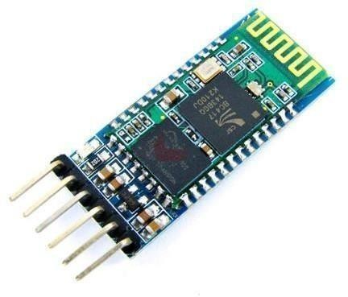

### Fig 4.4 : Bluetooth Module

**Features**

1. Support transparent transmitted with iPhone, integrated with the advantage of Bluetooth 4.0 BLE (Support iPhone 4s version above, cannot connect with the phone’s Bluetooth directly, need a BLE Bluetooth serial port assistant)
2. Compatible with HC-05 and HC-06 Bluetooth serial port module, Bluetooth 2.0 with EDR, 2 MBPS – 3 MBPS modulation
3. Built-in 2.4 GHz antennas, users need to debug the antenna
4. Support transparent transmitted with Android smartphone and notebook computer
5. Support transparent transmitted with desktop computer via HC-06-USB

## 4- CHANNEL RELAY

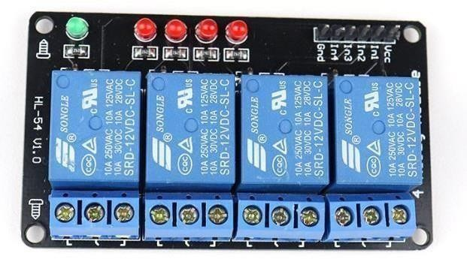

**Features**

### Fig 4.5 Relay

1. 4-Channel Relay interface board and each one needs 15-20mA Driver Current.
2. Both controlled by 12V and 5V input Voltage.
3. Equipped with high-current relay, AC250V 10A ; DC30V 10A.
4. Standard interface that can be controlled directly by microcontroller (Arduino, 8051, AVR, PIC, DSP, ARM, ARM, MSP430, TTL logic active low).
5. Indication LED’s for Relay output status.

## LCD I2C

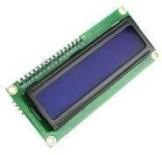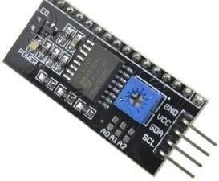

### Fig 4.6 : Lcd I2c

This is a RoHS compliant I2C Serial LCD Daughter board that can be connected to a standard 16×2 or 20×4 Character Display Module that supports 4-bit mode. All Character Modules sold on our site support 4-bit mode, and nearly all commercially available 16×2 and 20×4 line character modules support it too.

This board has a PCF8574 I2C chip that converts I2C serial data to parallel data for the LCD display. There are many examples on the internet for using this board with Arduino.

**Features**

1. 5V power supply.
2. Serial I2C control of LCD display using PCF8574.
3. Backlight can be enabled or disabled via a jumper on the board.
4. Contrast control via a potentiometer.
5. Can have 8 modules on a single I2C bus (change address via solder jumpers)address, allowing.
6. Size ：41.6 x 19.2 mm.

**SOFTWARES:**

This tutorial will walk you through downloading, installing, and testing the [Arduino software](http://arduino.cc/en/Main/Software) (also known as the Arduino IDE - short for Integrated Development Environment). Before you jump to the page for your operating system, make sure you've got all the right equipment.



##### Fig 4.10 Arduino Logo

Required Materials

 A computer (Windows, Mac, or Linux)

 An Arduino-compatible microcontroller (anything from [this guide](https://www.sparkfun.com/standard_arduino_comparison_guide) should work)

 A USB A-to-B cable, or another appropriate way to connect your Arduino-compatible microcontroller to your computer (check out this [USB buying guide](https://www.sparkfun.com/pages/USB_Guide) if you're not sure which cable to get).



##### Fig 4.11 : An Arduino Nano

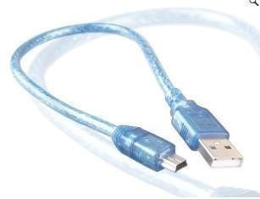

**Fig 4.12: An A-to-B USB Cable**

[How to Install CH340 Drivers](https://learn.sparkfun.com/tutorials/how-to-install-ch340-drivers) [AUGUST 6, 2019](https://learn.sparkfun.com/tutorials/how-to-install-ch340-drivers)

How to install CH340 drivers (if you need them) on Windows, Mac OS X, and Linux.

If you're ready to get started, click on the link in the column on the left that matches up with your operating system, or you can jump to your operating system here.

 [Windows](https://learn.sparkfun.com/tutorials/installing-arduino/windows)  [Mac](https://learn.sparkfun.com/tutorials/installing-arduino/mac)

 [Linux](https://learn.sparkfun.com/tutorials/installing-arduino/linux)

 Windows

This page will show you how to install and test the Arduino software with a Windows operating system (Windows 8, Windows 7, Vista, and XP).

 Go to the Arduino [download page](http://arduino.cc/en/Main/Software) and download the latest version of the Arduino software for Windows.

 When the download is finished, un-zip it and open up the Arduino folder to confirm that yes, there are indeed some files and sub-folders inside. The file structure is important so don't be moving any files around unless you really know what you're doing.

 Power up your Arduino by connecting your Arduino board to your computer with a USB cable (or FTDI connector if you're using an Arduino pro). You should see the an LED labed 'ON' light up. ([this diagram](https://learn.sparkfun.com/tutorials/what-is-an-arduino/whats-on-the-board) shows the placement of the power LED on the NANO).

Drivers for Arduino Nano on Windows

Installing the Drivers for the Arduino Nano (from Arduino.cc)

 Plug in your board and wait for Windows to begin it's driver installation process  After a few moments, the process will fail, despite its best efforts

 Click on the Start Menu, and open up the Control Panel

 While in the Control Panel, navigate to System and Security. Next, click on System  Once the System window is up, open the Device Manager

 Look under Ports (COM & LPT). You should see an open port named "Arduino NANO (COMxx)". If there is no COM & LPT section, look under 'Other Devices' for 'Unknown

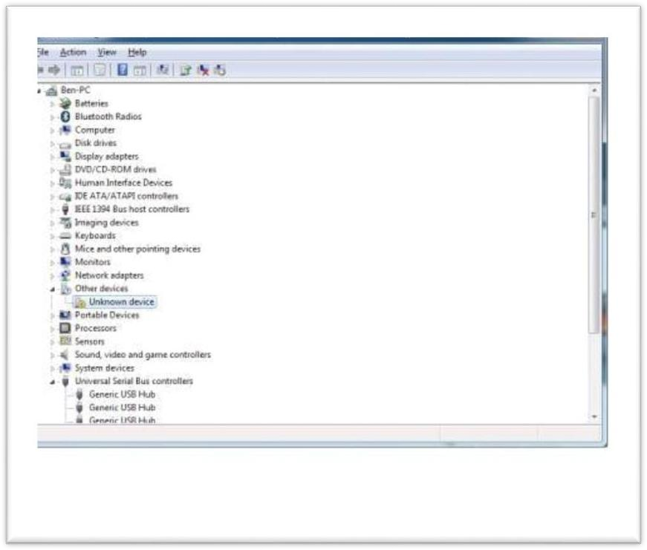

Device'

##### Fig 4.13: device manager

 Right click on the "Arduino NANO (COMxx)" or "Unknown Device" port and choose the "Update Driver Software" option

 Next, choose the "Browse my computer for Driver software" option

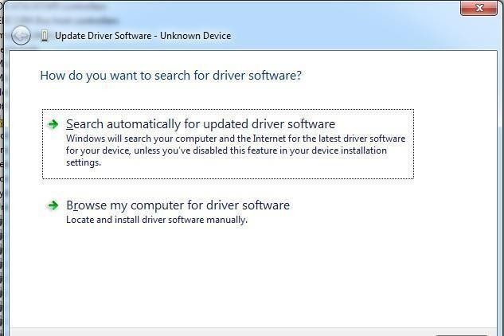

##### Fig 4.12update driver software

 Finally, navigate to and select the Nano's driver file, named "ArduinoNANO.inf", located in the "Drivers" folder of the Arduino Software download (not the "FTDI USB Drivers" sub- directory). If you cannot see the .inf file, it is probably just hidden. You can select the 'drivers' folder with the 'search sub-folders' option selected instead.

 Windows will finish up the driver installation from there

For earlier versions of the Arduino boards (e.g. ArduinoDuemilanove, Nano, or Diecimila) check out [this page](http://arduino.cc/en/Guide/Windows) for specific directions.

Drivers for RedBoard on Windows

If you are using a RedBoard programmed for Arduino, please go to [How to Install FTDI Drivers,](https://learn.sparkfun.com/tutorials/usb-serial-driver-quick-install-) for specific instructions on how to install the drivers.

[USB Serial Driver Quick Install](https://learn.sparkfun.com/tutorials/usb-serial-driver-quick-install-)

How to install USB serial drivers on Windows, MacOS , and Linux. Launch and Blink!

After following the appropriate steps for your software install, we are now ready to test your first program with your Arduino board!

 Launch the Arduino application

 If you disconnected your board, plug it back in

 Open the Blink example sketch by going to: File > Examples > 1.Basics > Blink

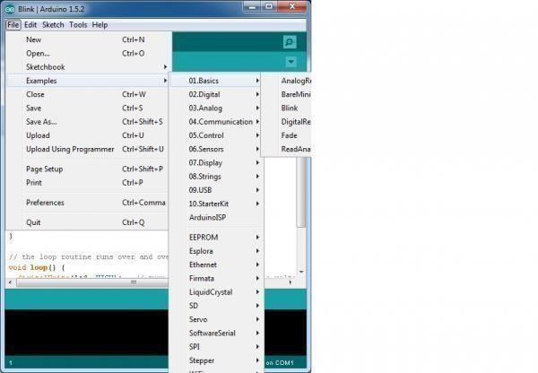

##### Fig 4.14 : examples

 Select the type of Arduino board you're using: Tools > Board > your board type

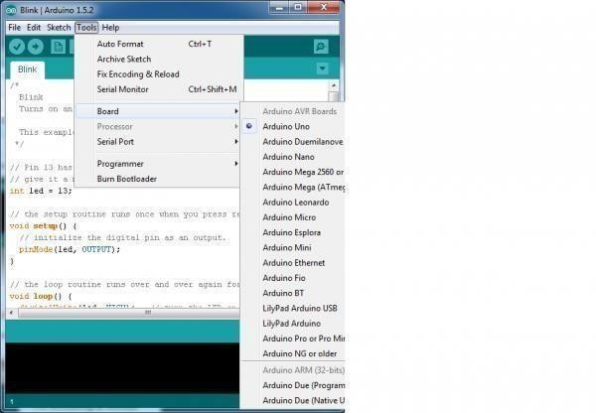

##### Fig 4.15 selection of board

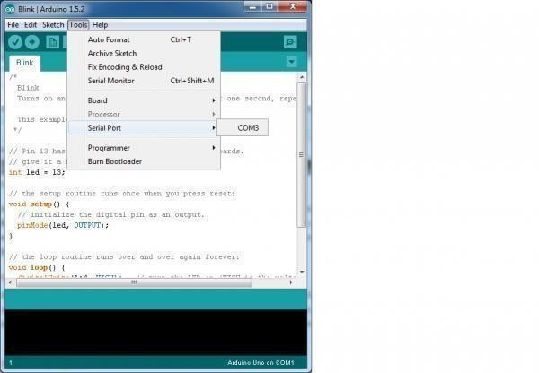 Select the serial/COM port that your Arduino is attached to: Tools > Port >COMxx

##### Fig 4.16 selection of serial port

 If you're not sure which serial device is your Arduino, take a look at the available ports, then unplug your Arduino and look again. The one that disappeared is your Arduino.

 With your Arduino board connected, and the Blink sketch open, press the 'Upload' button

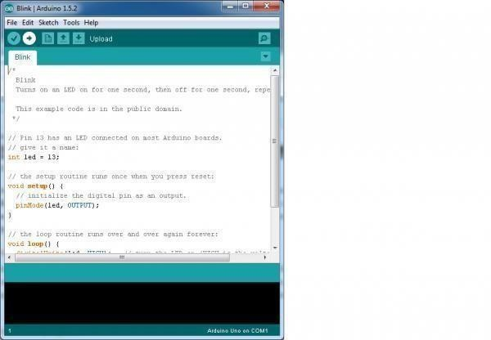

##### Fig 4.17 example code

 After a second, you should see some LEDs flashing on your Arduino, followed by the message 'Done Uploading' in the status bar of the Blink sketch.

 If everything worked, the onboard LED on your Arduino should now be blinking! You just programmed your first Arduino!

Troubleshooting

[This guide](http://arduino.cc/en/Guide/Windows) from Arduino has some more details and troubleshooting tips if you get stuck.

 Mac

This page will show you how to install and test the Arduino software on a Mac computer running OSX.

 Go to the Arduino [download page](http://arduino.cc/en/Main/Software) and download the latest version of the Arduino software for Mac.

 When the download is finished, un-zip it and open up the Arduino folder to confirm that yes, there are indeed some files and sub-folders inside. The file structure is important so don't be moving any files around unless you really know what you're doing.

 Power up your Arduino by connecting your Arduino board to your computer with a USB cable (or FTDI connector if you're using an Arduino pro). You should see the an LED labed 'ON' light up. ([this diagram](https://learn.sparkfun.com/tutorials/what-is-an-arduino/whats-on-the-board) shows the placement of the power LED on the NANO).

* Move the Arduino application into your Applications folder.

FTDI Drivers

If you have an NANO, Mega2560, or Redboard, you shouldn't need this step, so skip it!

 For other boards, you will need to install drivers for the FTDI chip on your Arduino.  Go to the [FTDI website](http://www.ftdichip.com/Drivers/VCP.htm) and download the latest version of the drivers.

 Once you're done downloading, double click the package and follow the instructions from the installer.

 Restart your computer after installing the drivers.

Launch and Blink!

After following the appropriate steps for your software install, we are now ready to test your first program with your Arduino board!

 Launch the Arduino application

 If you disconnected your board, plug it back in

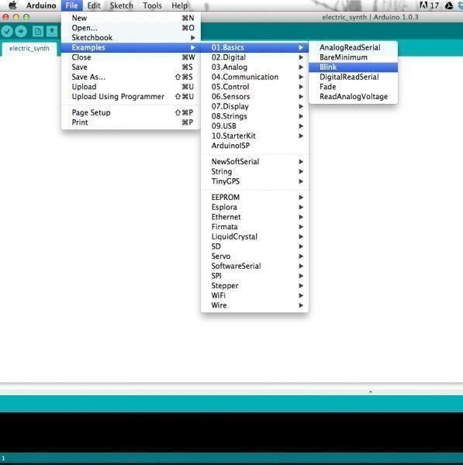

 Open the Blink example sketch by going to: File > Examples > 1.Basics > Blink

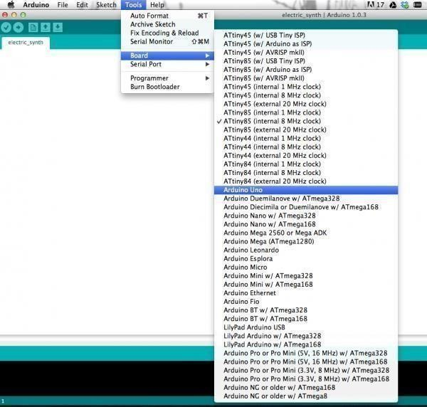

 Select the type of Arduino board you're using: Tools > Board > your board type

Fig 13 board selection in MAC

 Select the serial port that your Arduino is attached to: Tools > Port >xxxxxx (it'll probably look something like "/dev/tty.usbmodemfd131" or "/dev/tty.usbserial-131" but probably with a different number)

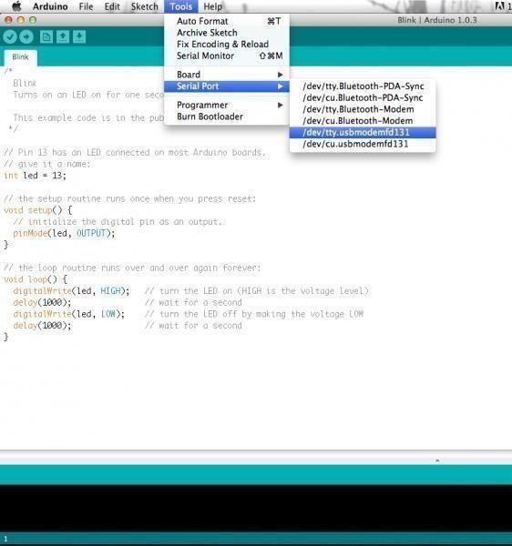

Fig 14 board selection in MAC

 If you're not sure which serial device is your Arduino, take a look at the available ports, then unplug your Arduino and look again. The one that disappeared is your Arduino.

 With your Arduino board connected and the Blink sketch open, press the 'Upload' button

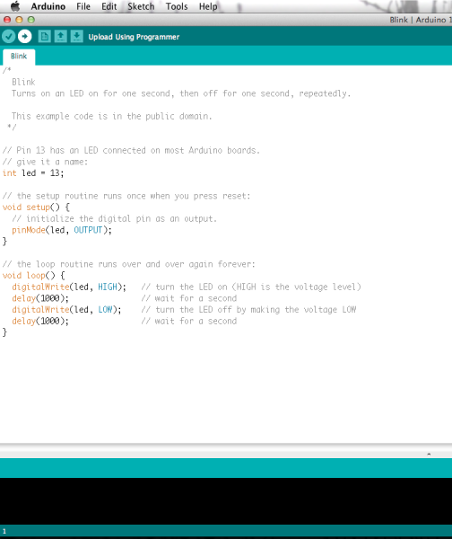

Fig 15 example code

 After a second, you should see some LEDs flashing on your Arduino, followed by the message 'Done Uploading' in the status bar of the Blink sketch.

 If everything worked, the onboard LED on your Arduino should now be blinking! You just programmed your first Arduino!

Troubleshooting

If you're having problems, check out [this troubleshooting guide](http://arduino.cc/en/Guide/Troubleshooting) from Arduino.

 Linux

If you are a Linux user, you probably know that there are many different distribution 'flavors' of Linux out there. Unsurprisingly, installing Arduino is slightly different for many of these distributions.

Luckily, the Arduino community has done an excellent job of providing instructions for most of the popular versions. Click on the link below that covers your flavor of Linux:

 [ArchLinux](http://playground.arduino.cc/Linux/ArchLinux)  [Debian](http://playground.arduino.cc/Linux/Debian)

 [Fedora](http://playground.arduino.cc/Linux/Fedora)



[Gentoo](http://playground.arduino.cc/Linux/Gentoo)

 [MEPIS](http://playground.arduino.cc/Linux/MEPIS)

 [Mint](http://playground.arduino.cc/Linux/Mint)

 [openSUSE](http://playground.arduino.cc/Linux/OpenSUSE)  [Puppy](http://playground.arduino.cc/Linux/Puppy)

 [Pussy](http://playground.arduino.cc/Linux/Pussy)

 [Slackware](http://playground.arduino.cc/Linux/Slackware)  [Ubuntu](http://playground.arduino.cc/Linux/Ubuntu)

 [Xandros (Debian derivative) on Asus Eee PC](http://playground.arduino.cc/Linux/Xandros)

If the above directions did not work for you, or you don't see your distribution, try this [catch-all guide.](http://playground.arduino.cc/Linux/All)

You can go to the [download page](http://arduino.cc/en/Main/Software) and download the latest version of Arduino for Linux (there are 32- bit and 64-bit versions available) when your system is properly set up.

Launch and Blink!

After following the appropriate steps for your software install, we are now ready to test your first program with your Arduino board!

 Launch the Arduino application

 If you disconnected your board, plug it back in

 Open the Blink example sketch by going to: File > Examples > 1.Basics > Blink  Select the type of Arduino board you're using: Tools > Board > your board type

 Select the serial port that your Arduino is attached to: Tools > Port >xxxxxx (it'll probably look something like "/dev/tty.usbmodemfd131" or "/dev/tty.usbserial-131" but probably with a different number)

 If you're not sure which serial device is your Arduino, take a look at the available ports, then unplug your Arduino and look again. The one that disappeared is your Arduino.

 With your Arduino board connected and the Blink sketch open, press the 'Upload' button

 After a second, you should see some LEDs flashing on your Arduino, followed by the message 'Done Uploading' in the status bar of the Blink sketch.

 If everything worked, the onboard LED on your Arduino should now be blinking! You just programmed your first Arduino!

Troubleshooting

The [Arduino Playground Linux section](http://playground.arduino.cc/Learning/Linux) is a great resource for figuring out any problems with your Arduino installation.

 Board Add-Ons with Arduino Board Manager

With Arduino v1.6.4+, a new boards manager feature makes it easy to add third-party boards (like the [SparkFunRedboard, Digital Sandbox, and RedBot](https://github.com/sparkfun/Arduino_Boards#sparkfun-arduino-boards)) to the Arduino IDE.

To start, highlight and copy (CTRL + C / CMD + C) the text below for the boards manager URL. You'll need this to configure Arduino.

COPY

CODEhttps://raw.githubusercontent.com/sparkfun/Arduino_Boards/master/IDE_Board_Manager/pac kage_sparkfun_index.json

Open up Arduino:

 Configure the Boards Manager

* For Windows and Linux, head to File>Preferences>Additional Boards Manager URLs and paste (CTRL + V / CMD + V) the link
* For Macs, head to Arduino>Preferences>Additional Boards Manager URLs and paste (CTRL + V / CMD + V) the link

 Click on Tools>Board>Boards Manager...

 Select the Type as "Contributed" from the drop down menu.  Click on the SparkFun AVR Boards and then click Install

That's it! Boards are all installed. This also gives you access to all of our library files as well through the built-in Library Manager tool in Arduino. Looking for more information about adding other customboards? Check out the the following [tutorial to install other Arduino cores.](https://learn.sparkfun.com/tutorials/installing-board-definitions-in-the-arduino-ide)

# CHAPTER 5: RESULTS

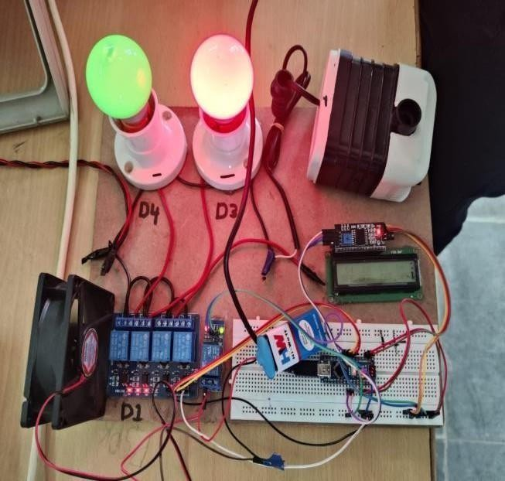

**Fig 5.1) Front View Of The Home Automation**

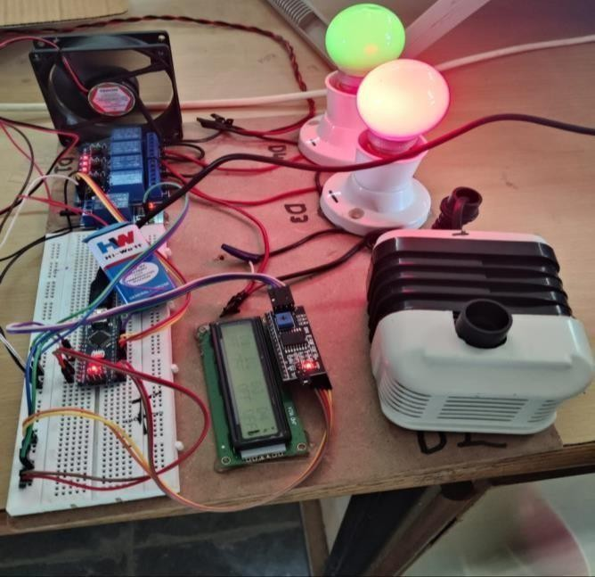

**Fig 5.12) Side View Of Home Automation**

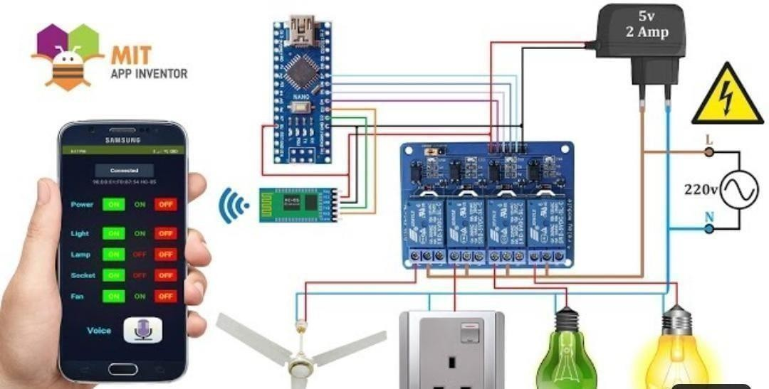

**Circuit Diagram Of Home Automation**

# CHAPTER 6: CONCLUISON

The system as the name indicates, ‘Home automation’ makes the system more flexible and provides attractive user interface compared to other home automation systems. In this system we integrate mobile devices into home automation systems. A novel architecture for a home automation system is proposed using the relatively new communication technologies. The system consists of mainly three components is a BLUETOOTH module, Arduino microcontroller and relay circuits. WIFI is used as the communication channel between android phone and the Arduino microcontroller. We hide the complexity of the notions involved in the home automation system by including them into a simple, but comprehensive set of related concepts. This simplification is needed to fit as much of the functionality on the limited space offered by a mobile device’s display. This paper proposes a low cost, secure, ubiquitously accessible, auto-configurable, remotely controlled solution. The approach discussed in the paper is novel and has achieved the target to control home appliances remotely using the WiFi technology to connects system parts, satisfying user needs and requirements. WiFi technology capable solution has proved to be controlled remotely, provide home security and is costeffective as compared to the previously existing systems. Hence we can conclude that the required goals and objectives of home automation system have been achieved. The system design and architecture were discussed, and prototype presents the basic level of home appliance control and remote monitoring has been implemented. Finally, the proposed system is better from the scalability and flexibility point of view than the commercially available home automation systems.

**CHAPTER 7** : **REFERENCES**

## REFERENCES

1. The official Bluetooth website from BluetoothSIG: [http://www.bluetooth.com](http://www.bluetooth.com/)
2. Neng- Shiang Liang; Li-Chen Fu; Chao-Lin Wu. “An integrated, flexible, and Internet-based control architecture for home automation system in the internet era”. Proceedings ICRA `02. IEEE International Conference on Robotics and Automation, Vol. 2, pp.1101-1106, 2012
3. K. Mandula, R. Parupalli, C. A. S. Murty, E. Magesh and R. Lunagariya, "Mobile based home automation using Internet of Things(loT)," 2015 International Conference on Control, Instrumentation, Communication and Computational Technologies (ICcrCCT), Kumaracoil, 2015, pp. 340-343.
4. D. Chowdhry, R. Paranjape and P. Laforge, "Smart home automation system for intrusion detection," 2015 IEEE 14th Canadian Workshop on information Theory (CWIT), St. John's, NL, 2015, pp. 75-78.
5. N. Skeledzija, J. C. Edin, V. Bachler, H. N. Vucemilo, H. Dzapo , "Smart home automation system for energy efficient housing", 37th International Convention on Information and Communication Technology, Electronics and Microelectronics (MIPRO), 2014, pp. 166-171

. [6] R. K. Kodali, V. Jain, S. Bose and L. Boppana, "loT based smart security and home automation system," 2016 Tnternational Conference on Computing, Communication and Automation (ICCCA), Noida, 2016, pp. 1286-1289.

1. R. Piyare and M. Tazil, "Bluetooth based home automation system using cell phone," 2011 IEEE 15th Tnternational Symposium on Consumer Electronics (ISCE), Singapore, 2011, pp. 192-195.
2. B. Ghazal and K. AI-Khatib, "Smart home automation system for elderly, and handicapped people using XBee," international Journal of Smart Home, vol. 9, no. 4, pp. 203- 210, Apr. 2015.
3. Rahul Gogawale, et aI., " Bluetooth remote home automation system using android application", international Engineering Research Journal (fERJ), vol. 2, no. 2, pp. 848- 850, 2016.
4. "Bluetooth Simple Terminal Application retrieved on June 19,2016 retrieved from < hltps:l/play.google.com/store/apps/details?id=wingood. bluetooth.btsimpleterminal&hl=en. [Accessed: 06-Feb-2017].